ARTIFICIAL INTELLIGENCE LAB MANUAL
Department of Computer Science and Engineering (CSE) -R22 Regulation

LIST OF EXPERIMENTS
Write a Program to Implement the following using Python.
1. Breadth First Search
2. Depth First Search
3. Tic-Tac-Toe game
4. 8-Puzzle problem
5. Water-Jug problem
6. Travelling Salesman Problem
7. Tower of Hanoi
8. Monkey Banana Problem
9. Alpha-Beta Pruning
10. 8-Queens Problem
EXPERIMENT 1: WRITE A PROGRAM TO IMPLEMENT BREADTH FIRST SEARCH USING PYTHON

INPUT GRAPH:
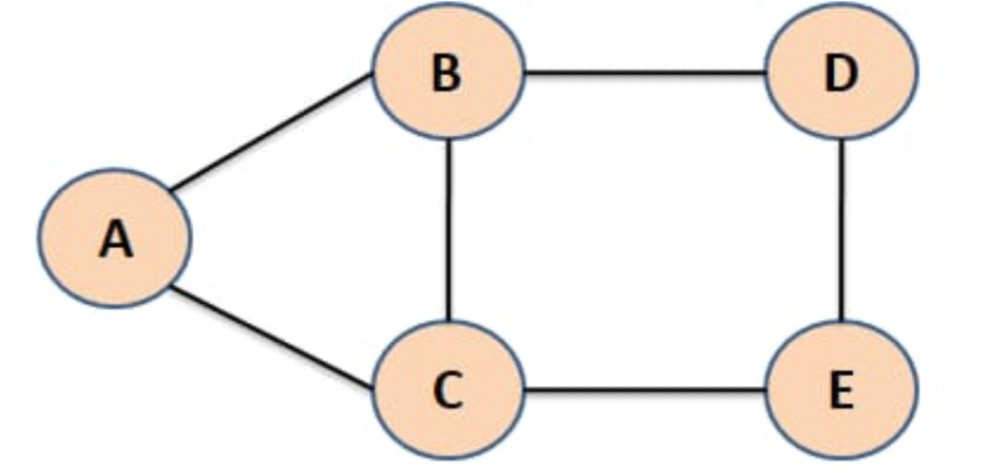
SOURCECODE: #
# Input Graph
graph = {
'A': ['B', 'C'],
'B': ['A', 'C', 'D'],
'C': ['A', 'B', 'E'],
'D': ['B', 'E'],
'E': ['C', 'D']
}

# To store visited nodes.
visitedNodes = []

# To store nodes in queue
queueNodes = []

# function
def bfs(visitedNodes, graph, snode):
visitedNodes.append(snode)
queueNodes.append(snode)
print()
print("RESULT :")
while queueNodes:
s = queueNodes.pop(0)
print(s, end=" ")
for neighbour in graph[s]:
if neighbour not in visitedNodes:
visitedNodes.append(neighbour)
queueNodes.append(neighbour)

# Main Code
snode = input("Enter Starting Node(A, B, C, D, or E) :").upper()

# calling bfs function
bfs(visitedNodes, graph, snode)

OUTPUT:
Sample Output 1:
Enter Starting Node (A, B, C, D, or E) : A
RESULT:
- B C D E
Sample Output 2:
Enter Starting Node(A, B, C, D, or E) : B
RESULT :
- A C D E

EXPERIMENT 2: WRITE A PROGRAM TO IMPLEMENT DEPTH FIRST SEARCH USING PYTHON
INPUT GRAPH:
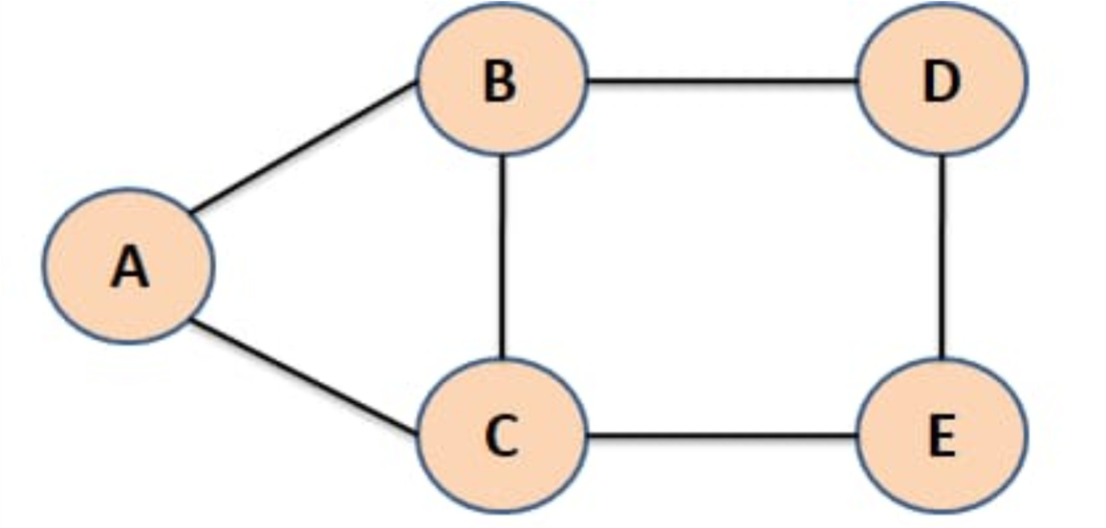
SOURCE CODE:
# Input Graph
graph = {
'A' : ['B','C'],
'B' : ['A','C','D'],
'C' : ['A','B','E'],
'D' : ['B','E'],
'E' : ['C','D']
}
# Set used to store visited nodes.
visitedNodes = list()
# function
def dfs(visitedNodes, graph, node):
if node not in visitedNodes:
print (node,end=" ")
visitedNodes.append(node)
for neighbour in graph[node]:
dfs(visitedNodes, graph, neighbour)
# Driver Code
snode = input("Enter Starting Node(A, B, C, D, or E): ").upper()
# calling bfs function
print("RESULT :")
print("-"*20)
dfs(visitedNodes, graph,snode)

OUTPUT:
Sample Output 1:
Enter Starting Node (A, B, C, D, or E) :A
RESULT :
- B C E D
Sample Output 2:
Enter Starting Node(A, B, C, D, or E) :B
RESULT :
- A C E D

EXPERIMENT 3: WRITE A PROGRAM TO IMPLEMENT TIC-TAC-TOE GAME USING PYTHON

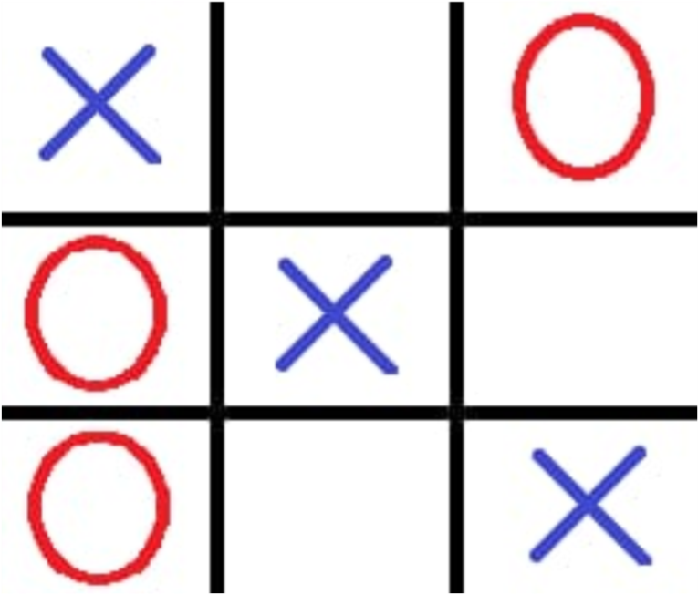

SOURCE CODE :
# Tuple to store winning positions.
win_positions = (
(0, 1, 2), (3, 4, 5), (6, 7, 8),
(0, 3, 6), (1, 4, 7), (2, 5, 8),
(0, 4, 8), (2, 4, 6)
)

# Function to display board and take player input
def game(player, mesh):

# Display current mesh
print("\n", " | ".join(mesh[:3]))
print("---+---+---")
print(" ", " | ".join(mesh[3:6]))
print("---+---+---")
print(" ", " | ".join(mesh[6:]))

# Loop until player enters valid input
while True:
try:
ch = int(input(f"\nEnter player {player}'s choice (1-9): "))
if ch < 1 or ch > 9 or mesh[ch-1] in ['X', 'O']:
raise ValueError
mesh[ch-1] = player
break
except ValueError:
print("Invalid position number. Try again.")

# Check win after move
return check_win(mesh, player, win_positions)

# Function to check win
def check_win(mesh, player, win_positions):
for wp in win_positions:
if all(mesh[pos] == player for pos in wp):
return wp
return None

# Main Program
player1 = "X"
player2 = "O"
player = player1

mesh = list("123456789")

for i in range(9):
won = game(player, mesh)

if won:
print("\n", " | ".join(mesh[:3]))
print("---+---+---")
print(" ", " | ".join(mesh[3:6]))
print("---+---+---")
print(" ", " | ".join(mesh[6:]))

print(f"\n*** Player {player} won! ***")
print("Winning positions:", won)
break

# Switch player
player = player1 if player == player2 else player2

else:
print("\nGame ends in a draw.")

OUTPUT:
Sample Output:
1 | 2 | 3
---+---+---
4 | 5 | 6
---+---+---
7 | 8 | 9
Enter player X's choice : 5
1 | 2 | 3
---+---+---
4 | X | 6
---+---+---
7 | 8 | 9

Enter player O's choice : 3
1 | 2 | O

---+---+---
4 | X | 6

---+---+---
7 | 8 | 9

Enter player X's choice : 1

X | 2 | O

---+---+---
4 | X | 6
---+---+---
7 | 8 | 9
Enter player O's choice : 6
X | 2 | O
---+---+---
4 | X | O
---+---+---
7 | 8 | 9
Enter player X's choice : 9
X | 2 | O
---+---+---
4 | X | O
---+---+---
7 | 8 | X
Player X won!

EXPERIMENT 4: WRITE A PROGRAM TO IMPLEMENT 8-PUZZLE PROBLEM USING PYTHON
from collections import deque

def bfs(start_state):
target = [1, 2, 3, 4, 5, 6, 7, 8, 0]
dq = deque([start_state])
visited = {tuple(start_state): None}

while dq:
state = dq.popleft()

if state == target:
path = []
while state:
path.append(state)
state = visited[tuple(state)]
return path[::-1]

zero = state.index(0)
row, col = divmod(zero, 3)
for move in (-3, 3, -1, 1):
new_pos = zero + move
if 0 <= new_pos < 9:
new_row, new_col = divmod(new_pos, 3)
if abs(row - new_row) + abs(col - new_col) == 1:
neighbor = state[:]
neighbor[zero], neighbor[new_pos] = neighbor[new_pos], neighbor[zero]

if tuple(neighbor) not in visited:
visited[tuple(neighbor)] = state
dq.append(neighbor)
def printSolution(path):
for state in path:
print(
"\n".join(
' '.join(map(str, state[i:i+3]))
for i in range(0, 9, 3)
),
end="\n----\n"
)
# Example Usage
startState = [1, 3, 0, 6, 8, 4, 7, 5, 2]
solution = bfs(startState)
if solution:
printSolution(solution)
print(f"Solved in {len(solution) - 1} moves.")
else:
print("No solution found.")
OUTPUT:
1 3 0
- 8 4
- 5 2
-----
1 3 4
- 8 0
- 5 2
-----
1 3 4
- 8 2
- 5 0
-----
1 3 4
- 8 2
- 0 5
-----
.
.
.
-----
1 2 3
4 5 0
7 8 6
-----
1 2 3
4 5 6
7 8 0
-----
Solved in 20 moves.

EXPERIMENT 5: Write a Program to Implement Water-Jug problem using Python.
Source code:

# jug1 and jug2 contain the value

jug1, jug2, goal = 4, 3, 2

# Initialize a 2D list for visited states
# The list will have dimensions (jug1+1) x (jug2+1) to cover all possible states
visited = [[False for _ in range(jug2 + 1)] for _ in range(jug1 + 1)]

def waterJug(vol1, vol2):
# Check if we reached the goal state
if (vol1 == goal and vol2 == 0) or (vol2 == goal and vol1 == 0):
print(vol1, "\t", vol2)
print("Solution Found")
return True

# If this state has been visited, return False
if visited[vol1][vol2]:
return False

# Mark this state as visited
visited[vol1][vol2] = True
# Print the current state
print(vol1, "\t", vol2)
# Try all possible moves
return (
waterJug(0, vol2) or # Empty jug1
waterJug(vol1, 0) or # Empty jug2
waterJug(jug1, vol2) or # Fill jug1
waterJug(vol1, jug2) or # Fill jug2
waterJug(
vol1 + min(vol2, (jug1 - vol1)),
vol2 - min(vol2, (jug1 - vol1))
) or # Pour water from jug2 to jug1
waterJug(
vol1 - min(vol1, (jug2 - vol2)),
vol2 + min(vol1, (jug2 - vol2))
) # Pour water from jug1 to jug2
)
print("Steps:")
print("Jug1 \t Jug2")
print("----- \t ------")

waterJug(0, 0)
OUTPUT:
Steps:
Jug1 Jug2
----- ------
0 0
4 0
4 3
0 3
3 0
- 3
- 2
0 2
Solution Found

EXPERIMENT 6: WRITE A PROGRAM TO IMPLEMENT TRAVELLING SALES PERSON USING PYTHON

SOURCE CODE:
from collections import deque

def tsp_bfs(graph):
n = len(graph) # Number of cities
startCity = 0 # Starting city
min_cost = float('inf') # Initialize minimum cost
opt_path = [] # Store optimal path

# Queue for BFS: (current_path, current_cost)
dq = deque([([startCity], 0)])

print("Path Traversal:")

while dq:
cur_path, cur_cost = dq.popleft()
cur_city = cur_path[-1]

# Print current traversal
print(f"Current Path: {cur_path}, Current Cost: {cur_cost}")

# If all cities are visited
if len(cur_path) == n:
total_cost = cur_cost + graph[cur_city][startCity]

if total_cost < min_cost:
min_cost = total_cost
opt_path = cur_path + [startCity]
continue

# Explore unvisited cities
for next_city in range(n):
if next_city not in cur_path:
new_path = cur_path + [next_city]
new_cost = cur_cost + graph[cur_city][next_city]
dq.append((new_path, new_cost))

return min_cost, opt_path

# Example graph as adjacency matrix
graph = [
[0, 10, 15, 20],
[10, 0, 35, 25],
[15, 35, 0, 30],
[20, 25, 30, 0]
]

# Solve TSP using BFS
min_cost, opt_path = tsp_bfs(graph)

print("\nOptimal Solution:")
print(f"Minimum cost: {min_cost}")
print(f"Optimal path: {opt_path}")

OUTPUT:
Path Traversal:
Current Path: [0], Current Cost: 0
Current Path: [0, 1], Current Cost: 10
Current Path: [0, 2], Current Cost: 15
Current Path: [0, 3], Current Cost: 20
Current Path: [0, 1, 2], Current Cost: 45
Current Path: [0, 1, 3], Current Cost: 35
Current Path: [0, 2, 1], Current Cost: 50
Current Path: [0, 2, 3], Current Cost: 45
Current Path: [0, 3, 1], Current Cost: 45
Current Path: [0, 3, 2], Current Cost: 50
Current Path: [0, 1, 2, 3], Current Cost: 75
Current Path: [0, 1, 3, 2], Current Cost: 65
Current Path: [0, 2, 1, 3], Current Cost: 75
Current Path: [0, 2, 3, 1], Current Cost: 70
Current Path: [0, 3, 1, 2], Current Cost: 80 Current Path: [0, 3, 2, 1], Current Cost: 85
Optimal Solution:
Minimum cost: 80
Optimal path: [0, 1, 3, 2, 0]

EXPERIMENT 7: WRITE A PROGRAM TO IMPLEMENT TOWER OF HANOI USING PYTHON.
SOURCE CODE:
def tower_of_hanoi(num, source, aux, target):
"""
num (int): Number of disks
source (str): Source tower
aux (str): Auxiliary tower
target (str): Target tower
"""
if num == 1:
print(f"Move disk 1 from {source} to {target}")
return

# Move num-1 disks from source to auxiliary
tower_of_hanoi(num - 1, source, target, aux)
# Move the largest disk to target
print(f"Move disk {num} from {source} to {target}")
# Move the num-1 disks from auxiliary to target
tower_of_hanoi(num - 1, aux, source, target)
# Example usage
num_disks = 3
tower_of_hanoi(num_disks, "A", "B", "C")

OUTPUT:
Move disk 1 from A to C
Move disk 2 from A to B Move disk 1 from C to B
Move disk 3 from A to C
Move disk 1 from B to A Move disk 2 from B to C
Move disk 1 from A to C
EXPERIMENT 8: WRITE A PROGRAM TO IMPLEMENT MONKEY BANANA PROBLEM USING PYTHON

SOURCE CODE:
from collections import deque

def monkey_banana_problem():
# Initial state
# (Monkey Location, Chair Position, Monkey Position, Monkey Status)
initial_state = (
'Far-Chair',
'Chair-Not-Under-Banana',
'Off-Chair',
'Empty'
)

print(f"\nInitial state is {initial_state}")

# Goal state: Monkey gets the banana
goal_state = (
'Near-Chair',
'Chair-Under-Banana',
'On-Chair',
'Holding'
)

# Possible actions and their effects
actions = {
"Move to Chair": lambda state: (
'Near-Chair', state[1], state[2], state[3]
) if state[0] != 'Near-Chair' else None,

"Push Chair under Banana": lambda state: (
'Near-Chair', 'Chair-Under-Banana', state[2], state[3]
) if state[0] == 'Near-Chair' and state[1] != 'Chair-Under-Banana' else None,

"Climb Chair": lambda state: (
'Near-Chair', 'Chair-Under-Banana', 'On-Chair', state[3]
) if state[0] == 'Near-Chair'
and state[1] == 'Chair-Under-Banana'
and state[2] != 'On-Chair' else None,

"Grasp Banana": lambda state: (
'Near-Chair', 'Chair-Under-Banana', 'On-Chair', 'Holding'
) if state[0] == 'Near-Chair'
and state[1] == 'Chair-Under-Banana'
and state[2] == 'On-Chair'
and state[3] != 'Holding' else None
}

# BFS queue: (current_state, actions_taken)
dq = deque([(initial_state, [])])
visited = set()

while dq:
current_state, actions_taken = dq.popleft()

# Goal test
if current_state == goal_state:
print("\nSolution Found!")
print("Actions to achieve goal:")
for action in actions_taken:
print(action)
print(f"Final State: {current_state}")
return

# Skip visited states
if current_state in visited:
continue

visited.add(current_state)

# Try all possible actions
for action_name, action_func in actions.items():
next_state = action_func(current_state)
if next_state and next_state not in visited:
dq.append((
next_state,
actions_taken + [
f"Action: {action_name}, Resulting State: {next_state}"
]
))

print("No solution found.")

# Run the program
monkey_banana_problem()

OUTPUT:
Initial state is ('Far-Chair', 'Chair-Not-Under-Banana', 'Off-Chair', 'Empty')
Solution Found!
Actions to achieve goal:
Action: Move to Chair, Resulting State: ('Near-Chair', 'Chair-Not-Under-Banana', 'Off-Chair', 'Empty')
Action: Push Chair under Banana, Resulting State: ('Near-Chair', 'Chair-Under-Banana', 'OffChair', 'Empty')
Action: Climb Chair, Resulting State: ('Near-Chair', 'Chair-Under-Banana', 'On-Chair', 'Empty')
Action: Grasp Banana, Resulting State: ('Near-Chair', 'Chair-Under-Banana', 'On-Chair', 'Holding')
Final State: ('Near-Chair', 'Chair-Under-Banana', 'On-Chair', 'Holding')

EXPERIMENT 9: WRITE A PROGRAM TO IMPLEMENT ALPHA-BETA PRUNING USING PYTHON

"""
Alpha Beta Pruning
------------------
depth (int): Current depth in the game tree
node_index (int): Index of the current node in the values list
maximizing_player (bool): True if maximizing player, False if minimizing
values (list): Leaf node values
alpha (float): Best value for maximizing player
beta (float): Best value for minimizing player

Returns:
int: Optimal value for the current player
"""

import math

def alpha_beta_pruning(depth, node_index, maximizing_player, values, alpha, beta):

# Base case: leaf node
if depth == 0 or node_index >= len(values):
return values[node_index]

if maximizing_player:
max_eval = -math.inf

for i in range(2): # Each node has two children
eval = alpha_beta_pruning(
depth - 1,
node_index * 2 + i,
False,
values,
alpha,
beta
)

max_eval = max(max_eval, eval)
alpha = max(alpha, eval)

if beta <= alpha:
break # Beta cutoff

return max_eval

else:
min_eval = math.inf

for i in range(2): # Each node has two children
eval = alpha_beta_pruning(
depth - 1,
node_index * 2 + i,
True,
values,
alpha,
beta
)

min_eval = min(min_eval, eval)
beta = min(beta, eval)

if beta <= alpha:
break # Alpha cutoff

return min_eval

# Example usage
if __name__ == "__main__":
# Leaf node values for a complete binary tree
values = [3, 5, 6, 9, 1, 2, 0, -1]

depth = 3 # Height of the tree
optimal_value = alpha_beta_pruning(
depth, 0, True, values, -math.inf, math.inf
)

print(f"The optimal value is: {optimal_value}")
OUTPUT:
The optimal value is: 5

EXPERIMENT 10: WRITE A PROGRAM TO IMPLEMENT 8-QUEENS USING PYTHON.
SOURCE CODE:
def printSolution(board):
"""Print the chessboard configuration."""
for row in board:
print(" ".join("Q" if col else "." for col in row))
print("\n")

def isSafe(board, row, col, n):
"""Check if placing a queen at board[row][col] is safe."""

# Check column
for i in range(row):
if board[i][col]:
return False

# Check upper-left diagonal
i, j = row, col
while i >= 0 and j >= 0:
if board[i][j]:
return False
i -= 1
j -= 1

# Check upper-right diagonal
i, j = row, col
while i >= 0 and j < n:
if board[i][j]:
return False
i -= 1
j += 1

return True

def solveNQueens(board, row, n):
"""Use backtracking to solve the N-Queens problem."""

if row == n:
printSolution(board)
return True

result = False

for col in range(n):
if isSafe(board, row, col, n):
# Place the queen
board[row][col] = 1

# Recur to place remaining queens
result = solveNQueens(board, row + 1, n) or result

# Backtrack
board[row][col] = 0

return result

def nQueens(n):
"""Driver function to solve the N-Queens problem."""
board = [[0] * n for _ in range(n)]

if not solveNQueens(board, 0, n):
print("No solution exists.")
else:
print("Solutions printed above.")

# Solve the 8-Queens problem
nQueens(8)

OUTPUT:
sssss